Subject Line: Glow Into the Holidays with Glossier ✨
Email: gTEAM@glossier.com

Headline: 20% your next order – Happy Holidays!
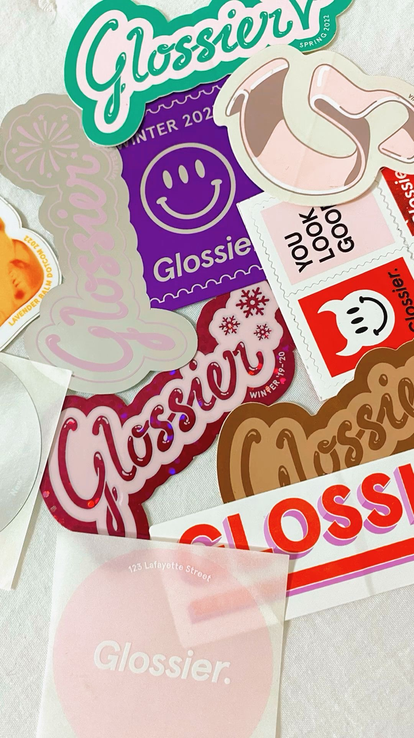
Happy Holidays from Glossier to you!

This holiday season, let your effortless beauty shine. Our new holiday collection is out now which includes our cult-favorite Hot Cocoa Balm Dotcom, the perfect chocolatey flavor with a light brown tint.

Shop our holiday sets that are perfect as stocking stuffers and some cute new festive merch for the winter season!

Use code GIFTFUL20 for 20% off your next order to have the perfect skin for the holiday season. As a little sweet treat for our loyal customers we’re doing free shipping the month of December!

Enjoy :) 💋

Glossier.com / gteam@glossier.com
233 Spring Street, Floor 10
New York, NY 10013

New Street Square
London, EC4A 3TW

To learn how we process data and monitor communications, please see our Privacy Policy, and Terms of Use.

No longer want to receive these emails? Unsubscribe

